Implementing Access Control in IEC 61860 using Key Graphs-
©Suhas Aggarwal (suhas@iitg.ernet.in)

A key graph can be utilized to achieve secure group communication among SIEDS.
Sub group keys set up in a key graph can be utilized to implement access control or we can also say a sub group can be formed within a publisher subscriber group on the basis of access rights of SIEDS, that is SIEDS having same views of the data of the publisher can be a part of same sub group.

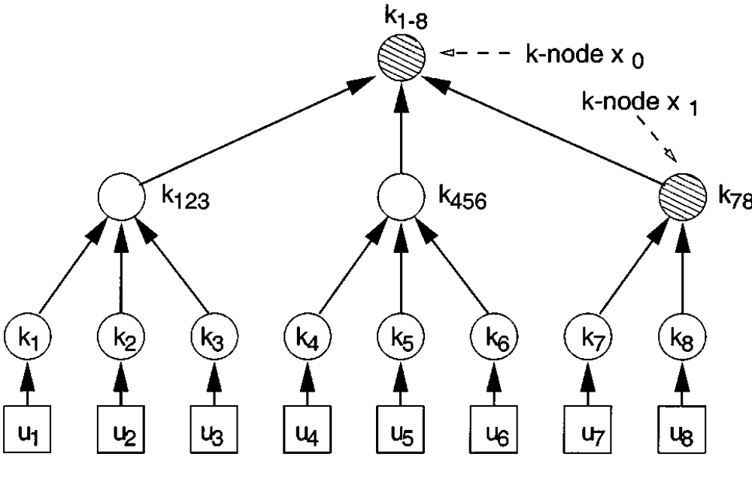

View1 View2 View3

This idea can be used to save number of packets that need to be constructed for individual subscribers, as separate packets having different data content will have to be constructed for subscribers having different access rights to the data ,sub groups can be formed on the basis of access views.
These packets can then be authenticated using respective subgroup keys and are copied into the local buffer from where they are multicasted to their respective subgroups.
Now, there is a question here, whether access control is strict or it just restricts unnecessary access and transfer of information.
In the former case, there is a sense of need for encryption in the control network as well...

